**Java Message Service (pub/sub)**

In a publish/subscribe (pub/sub) product or application, clients address messages to a topic, which functions somewhat like a bulletin board. Subscribers can receive information, in the form of messages, from publishers. Topics retain messages only as long as it takes to distribute them to current subscribers.

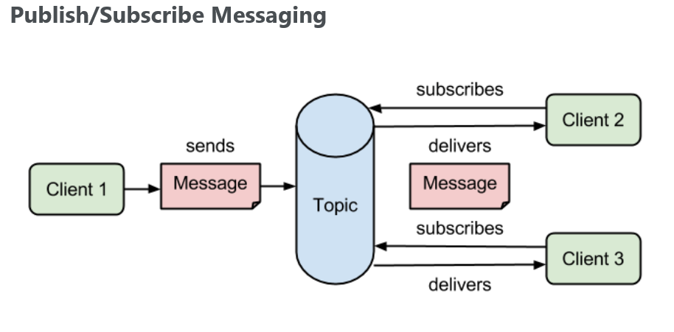

Pub/Sub messaging has the following characteristics:

* Each message can have **multiple consumers.**
* Publishers and subscribers have a **timing dependency.** A client that subscribes to a topic can consume only messages published after the client has created a subscription, and the subscriber must continue to be active in order for it to consume messages.

The JMS API **overcome** this timing dependency mentioned in the second point to some extent by allowing subscribers to create durable subscriptions, which receive messages sent while the subscribers are not active. **Durable subscriptions** provide the flexibility and reliability of queues but still allow clients to send messages to many recipients.

**ActiveMQ Example with Topic** (**Non Durable Subscription)**

**import** javax.jms.Connection;

**import** javax.jms.ConnectionFactory;

**import** javax.jms.JMSException;

**import** javax.jms.MessageProducer;

**import** javax.jms.Session;

**import** javax.jms.TextMessage;

**import** javax.jms.Topic;

**import** org.apache.activemq.ActiveMQConnectionFactory;

**public** **class** TopicProducer {

Connection connection;

Session session;

MessageProducer messageProducer;

String clientId;

String message;

String subject;

**public** **void** getConnection(String clientId,String topicName) **throws** JMSException {

**this**.clientId = clientId;

**this**.subject = topicName;

/*

* Getting JMS connection from the server and starting it

*/

ConnectionFactory connectionFactory = **new** ActiveMQConnectionFactory("tcp://localhost:61616");

connection = connectionFactory.createConnection();

// connection.setClientID(clientId);

session = connection.createSession(**false**, Session.***AUTO_ACKNOWLEDGE***);

Topic topic = session.createTopic(topicName);

messageProducer = session.createProducer(topic);

}

**public** **void** sendMessage(String message) **throws** JMSException {

**this**.message = message;

TextMessage textMessage = session.createTextMessage(message);

messageProducer.send(textMessage);

System.***out***.println("Message Sent: "+message);

}

**public** **void** closeConnection() **throws** JMSException {

connection.close();

}

}

**SubScriber:**

**import** javax.jms.Connection;

**import** javax.jms.ConnectionFactory;

**import** javax.jms.JMSException;

**import** javax.jms.Message;

**import** javax.jms.MessageConsumer;

**import** javax.jms.Session;

**import** javax.jms.TextMessage;

**import** javax.jms.Topic;

**import** org.apache.activemq.ActiveMQConnectionFactory;

**public** **class** TopicSubscriber_NonDurable {

Connection connection;

Session session;

MessageConsumer messageConsumer;

Topic topic;

**public** **void** getConnection(String clientId,String subject) **throws** JMSException{

/*

* Getting JMS connection from the server and starting it

*/

ConnectionFactory connectionFactory = **new** ActiveMQConnectionFactory("tcp://localhost:61616");

connection = connectionFactory.createConnection();

// connection.setClientID(clientId);

session = connection .createSession(**false**, Session.***AUTO_ACKNOWLEDGE***);

topic = session.createTopic(subject);

messageConsumer = session.createConsumer(topic);

connection.start();

}

**public** **void** getMessage() **throws** JMSException {

Message message = messageConsumer.receive(1000);

TextMessage textMessage = (TextMessage) message;

**if**(textMessage != **null**) {

String msg = textMessage.getText();

System.***out***.println("Message Recieved: "+msg);

}**else** {

System.***out***.println("Message Not Recieved...");

}

}

**public** **void** closeConnection() **throws** JMSException {

connection.close();

}

}

**Test:**

**import** javax.jms.JMSException;

**public** **class** TestNonDurable {

**public** **static** **void** main(String[] args) **throws** JMSException{

String clientProducer = "1234";

String msg = "Hello World";

String topicName = "testTopic";

TopicProducer producer = **new** TopicProducer();

producer.getConnection(clientProducer, topicName);

TopicSubscriber_NonDurable consumer1 = **new** TopicSubscriber_NonDurable();

consumer1.getConnection("abcd1", topicName);

TopicSubscriber_NonDurable consumer2 = **new** TopicSubscriber_NonDurable();

consumer2.getConnection("abcd2", topicName);

TopicSubscriber_NonDurable consumer3 = **new** TopicSubscriber_NonDurable();

consumer3.getConnection("abcd3", topicName);

producer.sendMessage(msg);

consumer1.getMessage();

consumer2.getMessage();

consumer3.getMessage();

consumer3.closeConnection();

producer.sendMessage("Hello World 2");

consumer1.getMessage();

consumer2.getMessage();

consumer3 = **new** TopicSubscriber_NonDurable();

consumer3.getConnection("abcd3", topicName);

consumer3.getMessage();

producer.closeConnection();

consumer1.closeConnection();

consumer2.closeConnection();

consumer3.closeConnection();

}

}

**Durable Subscription**

As mentioned in the beginning of this post it is also possible to create a durable subscription which allows to receive messages sent while the subscribers are not active. The JMS specification dictates that the identification of a specific durable subscription is done by a combination of the “***client ID”* ,** the ***“ durable subscription name”*** and the ***“topic name”.***

* The ***DurableSubscriber*** has three main differences with the previous ***Subscriber*** class:

1. A *clientId* is mandatory on the connection in order to allow a JMS provider to uniquely identify a durable subscriber.
2. A durable subscriber is created using *Session.createDurableSubscriber.*
3. A *subscriptionName* is needed when creating the durable subscriber.

**import** org.apache.activemq.ActiveMQConnectionFactory;

**public** **class** DurableSubscriber {

**private** String clientId;

**private** Connection connection;

**private** Session session;

**private** MessageConsumer messageConsumer;

**private** String subscriptionName;

**public** **void** create(String clientID, String topicName, String subscriptionName) **throws** JMSException {

**this**.clientId = clientID;

**this**.subscriptionName = subscriptionName;

ConnectionFactory connectionFactory = **new** ActiveMQConnectionFactory("tcp://localhost:61616");

connection = connectionFactory.createConnection();

connection.setClientID(**this**.clientId);

session = connection .createSession(**false**, Session.***AUTO_ACKNOWLEDGE***);

Topic topic = session.createTopic(topicName);

messageConsumer = session .createDurableSubscriber(topic, subscriptionName);

connection.start();

}

**public** **void** removeDurableSubscriber() **throws** JMSException {

messageConsumer.close();

session.unsubscribe(subscriptionName);

}

**public** **void** closeConnection() **throws** JMSException {

connection.close();

}

**public** **void** getMessage(**int** timeout) **throws** JMSException {

Message message = messageConsumer.receive(timeout);

**if**(message != **null**) {

TextMessage textMessage = (TextMessage) message;

String text = textMessage.getText();

System.***out***.println("Message Recieved: "+text);

}**else** {

System.***out***.println("Message not recieved");

}

}

}

**Test:**

**import** javax.jms.JMSException;

**import** com.test.apcahe.activemq.topic.nondurable.TopicProducer;

**public** **class** TestDurable {

**public** **static** **void** main(String[] args) **throws** JMSException{

String clientProducer = "1234";

String msg = "Hello World";

String topicName = "durableTopic";

TopicProducer producer = **new** TopicProducer();

producer.getConnection(clientProducer, topicName);

DurableSubscriber durableSubscriber = **new** DurableSubscriber();

durableSubscriber.create("durableClient1", "durableTopic" ,"durableSubscription");

durableSubscriber.closeConnection();

producer.sendMessage(msg);

durableSubscriber.create("durableClient1", "durableTopic" ,"durableSubscription");

producer.sendMessage("Hello World 2");

durableSubscriber.getMessage(1000);

durableSubscriber.getMessage(1000);

durableSubscriber.removeDurableSubscriber();

durableSubscriber.closeConnection();

producer.closeConnection();

}

}